**Microprocessor Lab  
Lab Experiment No. 6**

Name: Ninad Rao Roll No. 53

**Aim**: Perform multiplication of two numbers.

**Instructions on how to use TASM**:

Steps for creating the program:

1. TASM is loaded
2. TASM < Edit - We will get an edit window
3. Type the program here
4. Save the file as <filename>.asm

Steps for running the program:

1. c:\tasm> Type here tasm filename

**c:\tasm> tasm <filename>.asm**

This will save the program, and the edit window with this file name will be seen.

1. c:\tasm> Linking the program

**c:\tasm> tlink <filename>.obj**

This will create an object file after linking.

1. c:\tasm> Now to execute the program and get to the result window

**c:\tasm> td <filename>.exe**

After execution, all the window options are present to check all registers, all memory locations and so on.

**Program to multiply two numbers**:

**Explanation**: Consider that two unpacked numbers are present in the AL and BL registers. We have to multiply the two numbers. The result is stored in the AX register. The AAM (BCD adjust after Multiply) is used to adjust the product to two unpacked BCD digits in AX.

**Algorithm**:

**Step I:** Initialize the data segment.

**Step II:** Get the first unpacked BCD number.

**Step III:** Get the second unpacked BCD number.

**Step IV:** Multiply the two numbers.

**Step V:** Adjust result to valid unpacked BCD number in AX.

**Step VI:** Display the result.

**Step VII:** Stop.

**Flowchart**:

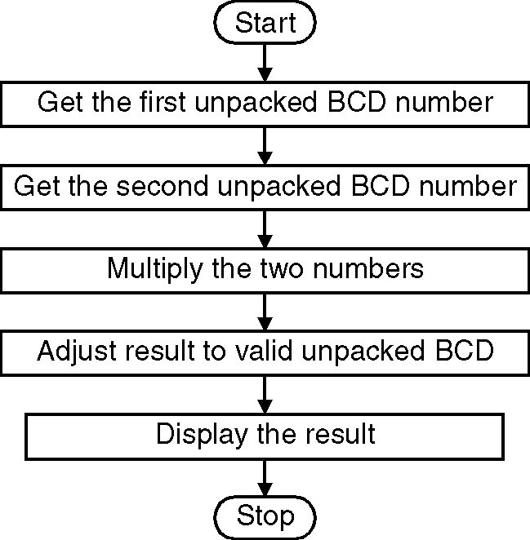

**Code**:

.model small

.data

a db 04H

b db 06H

.code

mov ax, @data ; Initialize data section

mov ds, ax

mov ah, 0

mov al, a ; Load number1 in al

mov bl, b ; Load number2 in bl

mul bl ; Multiply numbers and result in ax

aam ; Adjust result to valid unpacked BCD

mov ch, 04h ; Count of digits to be displayed

mov cl, 04h ; Count to roll by 4 bits

mov bx, ax ; Result in reg bx

l2: rol bx, cl ; Roll bl so that msb comes to lsb

mov dl, bl ; Load dl with data to be displayed

and dl, 0Fh ; Get only lsb

cmp dl, 09 ; Check if digit is 0-9 or letter A-F

jbe l4

add dl, 07 ; If letter add 37H else only add 30H

l4: add dl, 30H

mov ah, 02 ; Function 2 under INT 21H (Display character)

int 21H

dec ch ; Decrement Count

jnz l2

mov ah, 4cH ; Terminate Program

int 21H

end

**Output**:

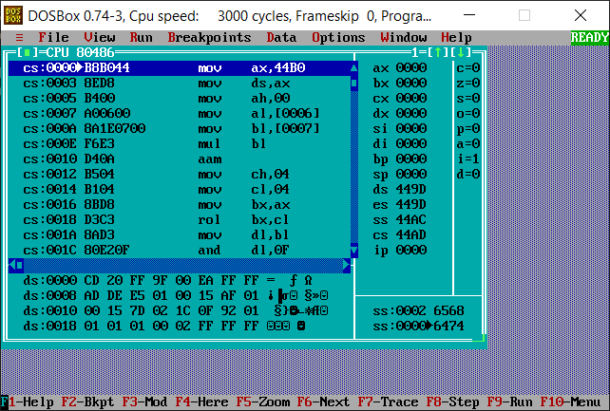

**Conclusion**: Thus, we have studied and understood the program to multiply two numbers.